1 class A

{

Public static void main(String args[])

{

System.out.println("Hello world");

}

}

Output:

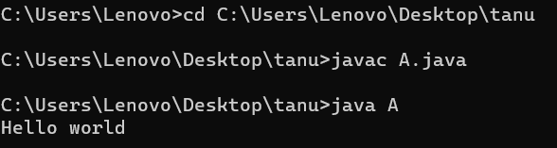

**2.Write a demo program on Data Types?**

public class primitiveDemo

{

public static void main(String args[])

{

byte b=100;

short s=986;

int v=89076;

int calc=63289;

long amountVal=1234567891;

float interestRate=25.5f;

double sineVal=567.8d;

boolean flag=true;

boolean val=false;

char ch1=45;

char ch2='x';

System.out.println("Byte value:"+b);

System.out.println("Short value:"+s);

System.out.println("Int value:"+v);

System.out.println("Int second value:"+calc);

System.out.println("Long value:"+amountVal);

System.out.println("Float value:"+v);

System.out.println("Double value:"+v);

System.out.println("Boolean value:"+flag);

System.out.println("Byte value:"+val);

System.out.println("Char value:"+ch1);

System.out.println("Char value:"+ch2);

}

}

**Output:**

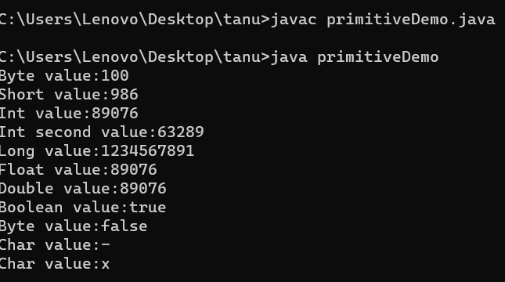

**3 Write a demo program on type conversion.**

class typeconversion

{

public static void main(String args[])

{

char ch1='B';

double d1=ch1;

System.out.println(d1);

System.out.println(ch1*ch1);

double d2=99.0;

char ch2=(char)d2;

System.out.println(ch2);

}

}

**Output:**

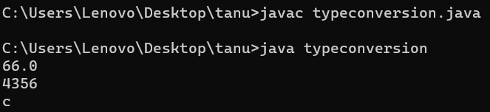

**4 Write a Demo program on one dimensional array.**

class Average

{

public static void main(String args[])

{

double num[]={10.1,11.2,12.3,13.4,14.5};

double result=0;

for(int i=0;i<5;i++)

result=result+num[i];

System.out.println("Average of numbers:"+result/5);

}

}

**Output:**

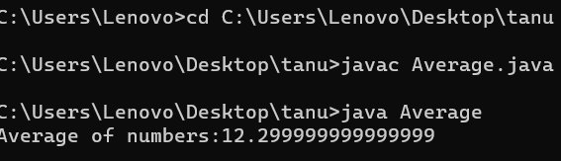

**5 Write a demo program on two dimensional array.**

class twoD

{

public static void main(String args[])

{

int a[][]=new int[2][2];

int b[][]=new int[2][2];

a[0][0]=1;

a[0][1]=2;

a[1][0]=3;

a[1][1]=4;

b[0][0]=5;

b[0][1]=6;

b[1][0]=7;

b[1][1]=8;

int c[][]=new int[2][2];

System.out.println("Elements of first matrix:");

for(int i=0;i<2;i++)

{

for(int j=0;j<2;j++)

{

System.out.println(a[i][j]);

}

}

System.out.println("Elements of second matrix:");

for(int i=0;i<2;i++)

{

for(int j=0;j<2;j++)

{

System.out.println(b[i][j]);

}

}

for(int i=0;i<2;i++)

{

for(int j=0;j<2;j++)

{

c[i][j]=a[i][j]+b[i][j];

}

}

System.out.println("Sum of two matrices:");

for(int i=0;i<2;i++)

{

for(int j=0;j<2;j++)

{

System.out.println(c[i][j]);

}

}

}

}

**Output:**

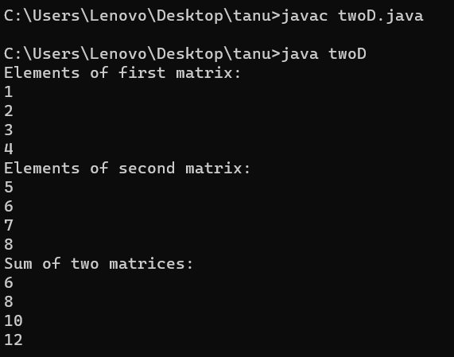

**6 Write a demo program on Arithmetic operators.**

import java.util.Scanner;

class Arithmetic

{

public static void main(String args[])

{

int a,b;

System.out.println("Value of a and b:");

Scanner input=new Scanner(System.in);

a=input.nextInt();

b=input.nextInt();

System.out.println("Addition:"+(a+b));

System.out.println("Subtraction:"+(a-b));

System.out.println("Multiplication:"+(a*b));

System.out.println("Division:"+(a/b));

}

}

**Output:**

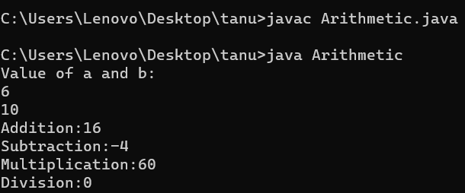

**7 Write a demo program on relational operators**

import java.util.Scanner;

class Relational

{

public static void main(String args[])

{

int a,b;

System.out.println("Value of a and b:");

Scanner input=new Scanner(System.in);

a=input.nextInt();

b=input.nextInt();

System.out.println("Greater than operator(a>b):"+(a>b));

System.out.println("Greater than or equal to operator(a>=b):"+(a>+b));

System.out.println("Less than operator(a<b):"+(a<b));

System.out.println("Less than or equal to operator(a<+b):"+(a<=b));

System.out.println("Equal to operator(a==b):"+(a==b));

System.out.println("Not equal to operator(a!=b):"+(a!=b));

}

}

**Output:**

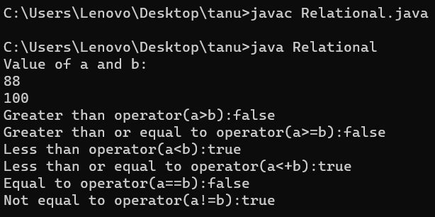

8 Write a demo program on bitwise operators.

public class Bitwise

{

public static void main(String args[])

{

int a=90;

int b=70;

int c=0;

c=a&b;

System.out.println("a&b="+c);

c=a|b;

System.out.println("a|b="+c);

c=a^b;

System.out.println("a^b="+c);

c=a<<5;

System.out.println("a<<5="+c);

c=a>>5;

System.out.println("a>>5="+c);

c=-a;

System.out.println("-a="+c);

}

}

**Output:**

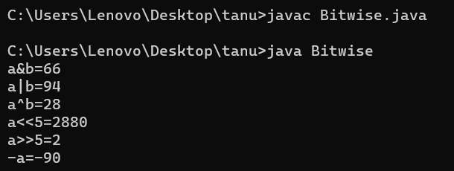

**9 Write a program to print elements in matrix form.**

class matrix

{

public static void main(String args[])

{

int a[][]=new int[2][2];

int b[][]=new int[2][2];

a[0][0]=11;

a[0][1]=22;

a[1][0]=33;

a[1][1]=44;

b[0][0]=55;

b[0][1]=66;

b[1][0]=77;

b[1][1]=88;

int c[][]=new int[2][2];

System.out.println("Elements of first matrix:");

for(int i=0;i<2;i++)

{

for(int j=0;j<2;j++)

{

System.out.println(a[i][j]+" ");

}

}

System.out.println("Elements of second matrix:");

for(int i=0;i<2;i++)

{

for(int j=0;j<2;j++)

{

System.out.println(b[i][j]+" ");

}

}

for(int i=0;i<2;i++)

{

for(int j=0;j<2;j++)

{

c[i][j]=a[i][j]+b[i][j];

}

}

System.out.println("Addition of two matrices:");

for(int i=0;i<2;i++)

{

for(int j=0;j<2;j++)

{

System.out.println(c[i][j]+" ");

System.out.println();

}

}

}

}

**Output:**

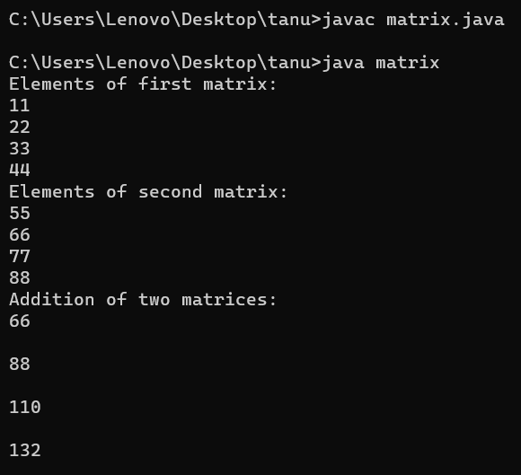

**10 Write a program to print stars in increasing triangular format**

public class leftTrianglePattern

{

public static void main(String args[])

{

int n = 5;

for (int i = 1; i <= n; i++)

{

for (int j = 1; j <= i; j++)

{

System.out.print("* ");

}

System.out.println();

}

}

}

**Output:**

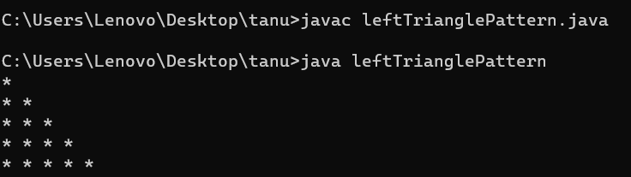

**11 Write a demo program on conditional operator**

public class conditional

{

public static void main(String args[])

{

int a,b;

a=90;

b=(a==1)?30:40;

System.out.println("Value of b is:"+b);

b=(a==90)?30:40;

System.out.println("Value of b is:"+b);

}

}

**Output:**

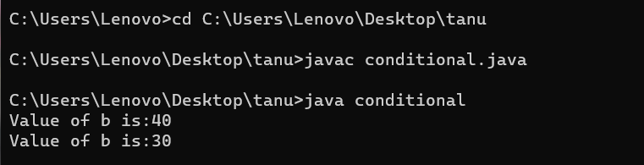

**12 Write a demo program on Instance of operator**

public class InstanceOfOperator

{

public static void main(String args[])

{

String name="Vinni";

boolean result=name instanceof String;

System.out.println(result);

}

}

**Output:**

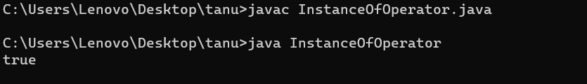

**13**

class Vehicle

{

}

public class Car extends Vehicle

{

public static void main(String args[])

{

Vehicle ve=new Car();

boolean result=ve instanceof Car;

System.out.println(result);

}

}

**Output:**

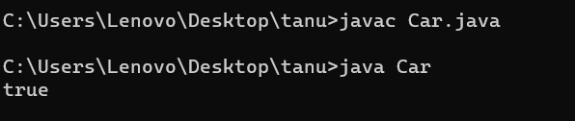

**14 Write a demo program on if statement**

class If

{

public static void main(String args[])

{

int test=8;

if (test<7)

{

System.out.println("Success");

}

System.out.println("Executed successfully");

}

}

**Output:**

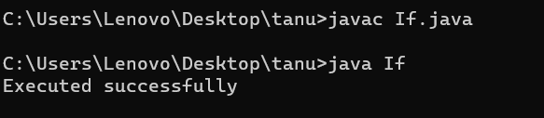

**15** **Write a demo program on if else statement**

class ifelse

{

public static void main(String args[])

{

int test=100;

if(test==100)

{

System.out.println("the value is equal to 100");

}

else

{

System.out.println("Value not equal to 100");

}

}

}

Output:

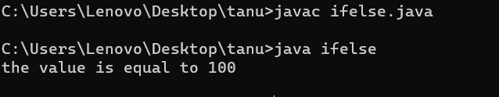

**16 Write a demo program on nested ifelse statement**

public class NestedIfElse

{

public static void main(String args[])

{

int test1=3;

int test2=3;

if(test1==5)

{

if(test2==3)

{

System.out.println("hi,test1 is 5 and test2 is 3");

}

else

{

System.out.println("test1 is 5 and test2 is somevalue is other than 3");

}

}

else if(test1==4)

{

System.out.println("hi,test1 is 3 and test2 is 3");

}

else if(test1==3)

{

if(test2==3)

{

System.out.println("hi,test1 is 5 and test2 is 3");

}

else if(test2==2)

{

System.out.println("hi,test1 is 3 and test2 is 2");

}

}

else

System.out.println("hi,test1 is somevalue other than 5,4,3");

}

}

**Output:**

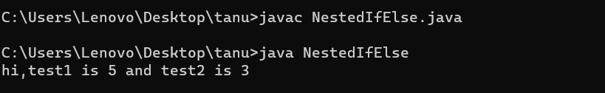

**17 Write a program on while loop**

class While

{

public static void main(String args[])

{

int arr[]={2,11,45,9};

int i=0;

while(i<4)

{

System.out.print(arr[i]+"");

i++;

}

}

}

**Output:**

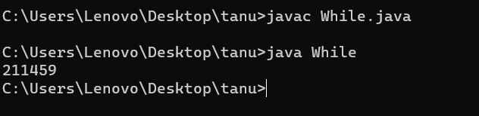

**18 Write a demo program on If-else ladder**

public class Ifelseladder

{

public static void main(String args[])

{

int test=2;

if(test==1)

System.out.println("Hi");

else if(test==2)

System.out.println("Hello");

else if(test==3)

System.out.println("Namaste");

else

System.out.println("No match found");

}

}

**Output:**

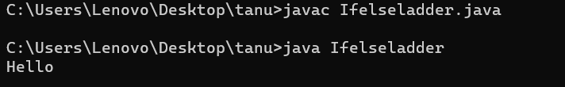

**19 write a demo program on do-while**

class DoWhile

{

public static void main(String args[])

{

int i=10;

do

{

System.out.println(i);

i--;

}

while(i<1);

}

}

**Output:**

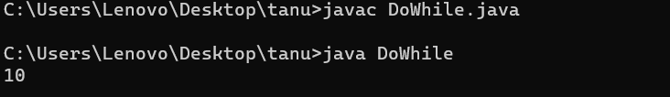

**20 Write a demo program on switch**

class Switch

{

public static void main(String args[])

{

int month=2;

int year=2000;

int numDays=0;

switch(month)

{

case 1:

case 3:

case 5:

case 7:

case 8:

case 10:

case 12:

numDays=31;

break;

case 2:

if(((year%4==0)&&!(year%100==0))||(year%400==0))

numDays=29;

else

numDays=28;

break;

default:

System.out.println("Invalid month");

break;

}

System.out.println("Number of days="+numDays);

}

}

**Output:**

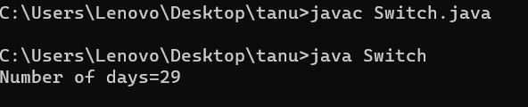

**21**

class Pyramid

{

public static void main(String args[])

{

int depth=10;

int s=depth,m;

for(int i=1;i<depth;i++)

{

m=4;

while(s>0)

{

System.out.println("");

s--;

}

for(int j=1;j<=i;j++)

{

System.out.print("*");

}

s=m-1;

System.out.println("");

}

}

}

**Output:**

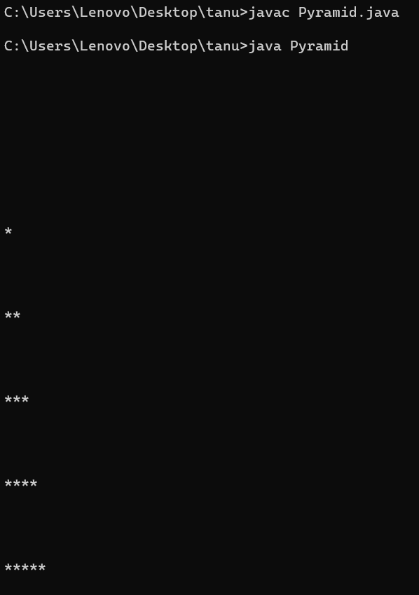

1. **Write a program on Break statement.**

class Break

{

public static void main(String args[])

{

for(int x=0;x<50;x++)

{

if(x==5)

{

break;

}

System.out.println("Value of x is:"+x);

}

System.out.println("Breaked out of loop ");

}

}

**Output:**

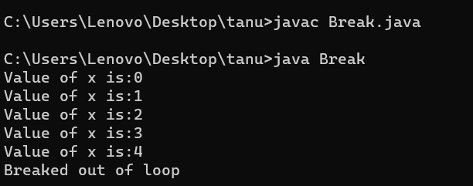

1. **Write a program on continue statement**

class Continue

{

public static void main(String args[])

{

int i;

for(i=0;i<10;i++)

{

if(i==5)

continue;

System.out.println(i);

}

}

}

**Output:**

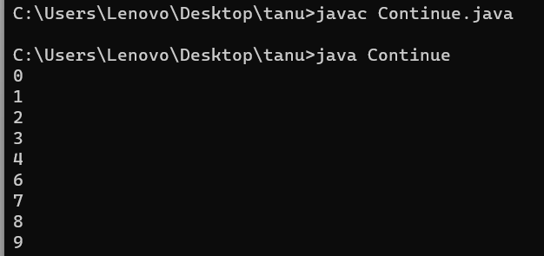

**24.Write a program to find Minimum Number using Functions**

public class MinimumNumber

{

public static void main(String args[]){

int a=12;

int b=10;

int c=minFunction(a,b);

System.out.println("Minimum value is:"+c);

}

public static int minFunction(int n1,int n2)

{

int min;

if(n1>n2)

min=n2;

else

min=n1;

return min;

}

}

**Output:**

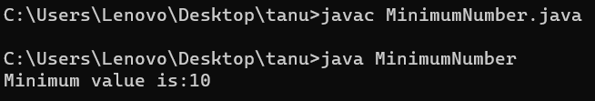

**25 Write a program on THIS for instance variable**

**26 Write a program on DefaultConstructor**

public class DefaultConstructor

{

public DefaultConstructor()

{

System.out.println("Iam inside default constructor");

}

public static void main(String args[])

{

DefaultConstructor dc=new DefaultConstructor();

}

}

**Output:**

